# Workshop: Personal Portfolio

The workshop is part of the ["JavaScript For Front-End Course @ SoftUni"](https://softuni.bg/trainings/2032/javascript-for-front-end-july-2018#lesson-8965).

It’s time to create your first personal portfolio using **Bootstrap**, **CSS Preprocessors** & **Plugins**.

Submit your **portfolio** at the course [page](https://softuni.bg/trainings/2032/javascript-for-front-end-july-2018#lesson-8976) and wait for your colleagues’ reviews.

It’s **NOT** mandatory to follow this design. You can create your **own** **personal** **portfolio**, just follow these constraints.

## Constraints:

* Your design should be created using [Bootstrap](https://getbootstrap.com/).
* Your custom **CSS** should be written on [SASS](https://sass-lang.com/).
* Your portfolio should be **responsive** – Good reason to use [Bootstrap Grid System](https://getbootstrap.com/docs/4.0/layout/grid/).
* You can add some additional **functionality**, using [Bootstrap Plugins](https://startbootstrap.com/bootstrap-resources) or [jQuery Plugins](https://speckyboy.com/free-jquery-plugins/).
* You should **create** (or **copy**, just be careful with **copyrights**) and **import** your own [favicon](https://www.favicon-generator.org/).
* You will be a real superhero if you **host** your portfolio in [Github Pages](https://pages.github.com/).

## Getting started with Bootstrap

First, you should download the **Bootstrap** **library** from official [website](https://getbootstrap.com/). After that you should create your **folder** **structure** and **initial** **page**:

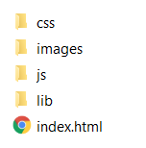

You should include **all** **Bootstrap** **files** that you downloaded + [jQuery](https://jquery.com/).

### 2. 1. Theming Bootstrap

For our portfolio we should use **free** **Bootstrap** **theme** from [Bootswatch](https://bootswatch.com/). The theme that we will use in this workshop is [Minty](https://bootswatch.com/minty/), but you can use another one if you like it more. Simply download the **theme** **CSS** file and **replace** the one in **Bootstrap**. Now it’s time to look at our **page** **structure**. It can be whatever you like so you are free to **design** it for yourself.

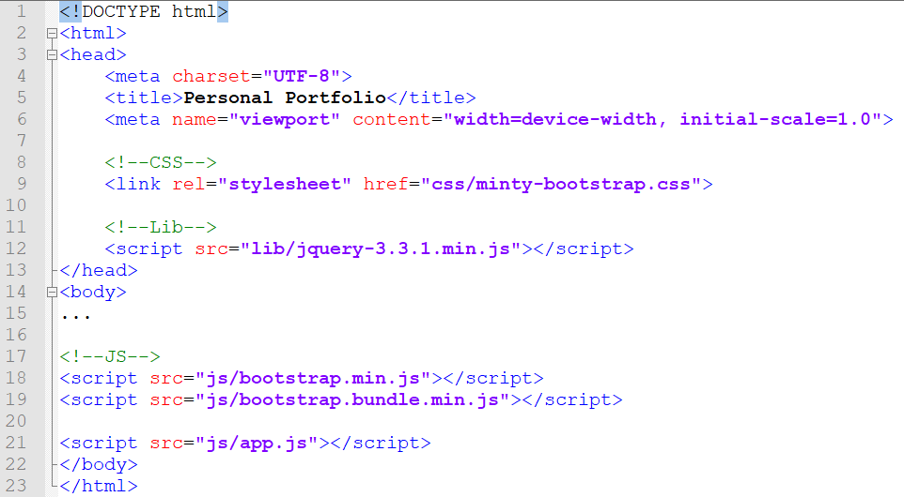

## Getting started with SASS

First, make sure that you have **installed** [Node.js](https://nodejs.org/en/).

Install **SASS** from your [terminal](https://www.npmjs.com/package/node-sass).

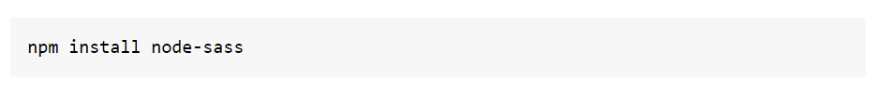

Configure your **IDE** to compile **SASS** to **CSS**.

* [WebStorm](https://www.jetbrains.com/help/webstorm/transpiling-sass-less-and-scss-to-css.html)

In the **Settings/Preferences** dialog click **File Watchers** under **Tools**. The [File Watchers page](https://www.jetbrains.com/help/webstorm/settings-tools-file-watchers.html) that opens, shows the list of File Watchers that are already configured in the project.

Click “**+**” or press Alt + Insert. Choose the **SCSS** predefined template from the list.

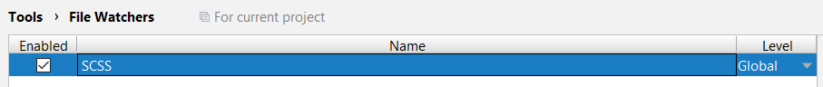

In **AppData\Roaming\npm** find your **node-sass.cmd** file and make sure you have the following **settings**.

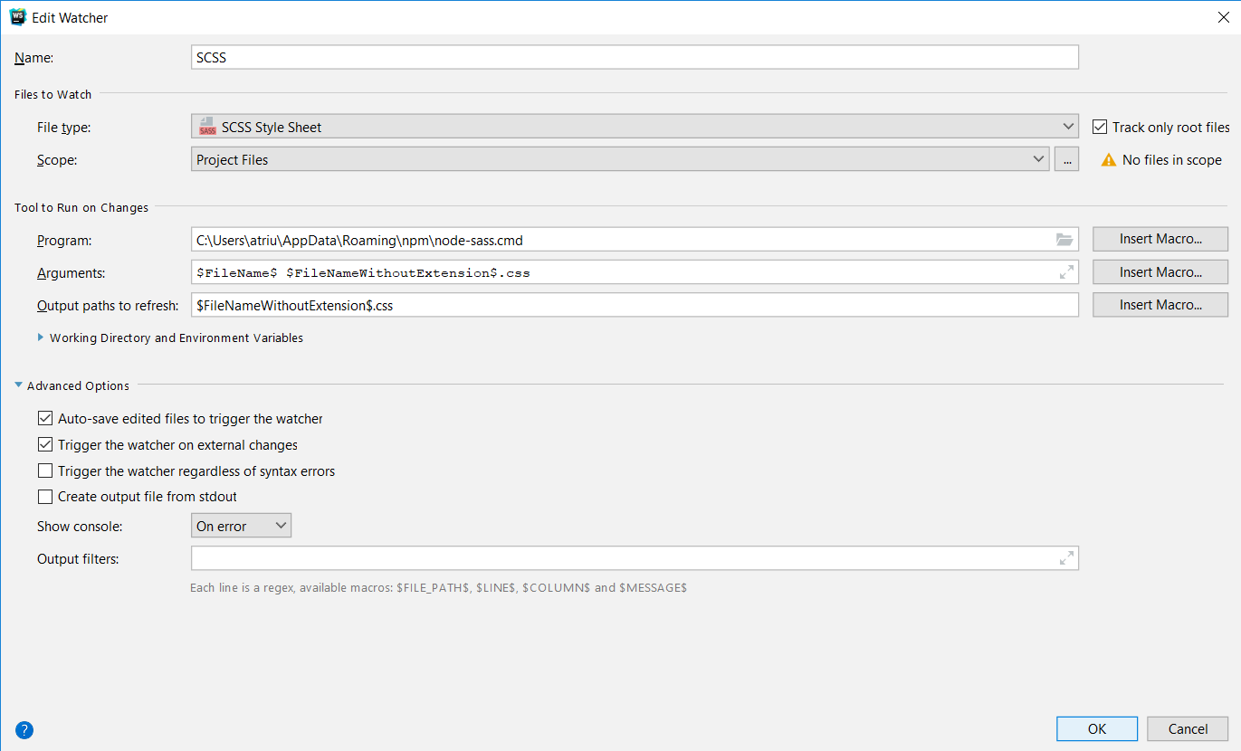

Create your first **SCSS** file and write some **Syntactically** **Awesome** **Style** **Sheets.**

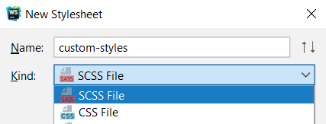

More about SASS Syntax [here](https://sass-lang.com/guide).

## Create Portfolio Page with Bootstrap

We will need to implement a **navigation** bar. You can look at the **theme** **documentation** we can see what kind of components it offers us.

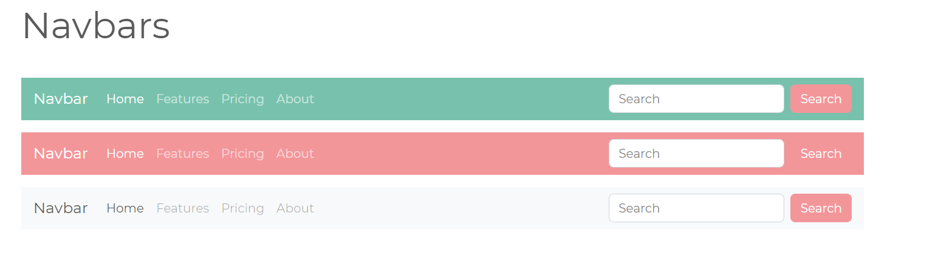

Well, our idea is similar but it will need some **changes**.



Our first section is **About**. In our theme documentation we can see how we can create a **container**.   
After that we would just need to **center** the **container** and to change the content inside.

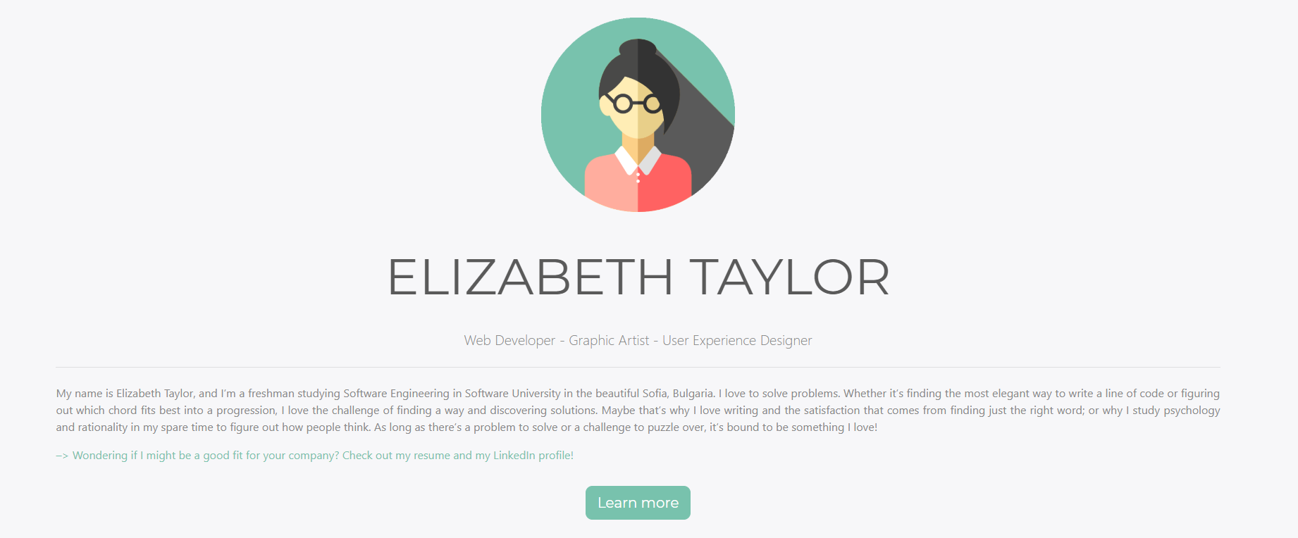

The next sections we need to implement are the **Experience** and **Skills** sections. They are similar to each other.

We have to create some **cards** and **progress** **bar** **templates** and add a little more **content** inside.

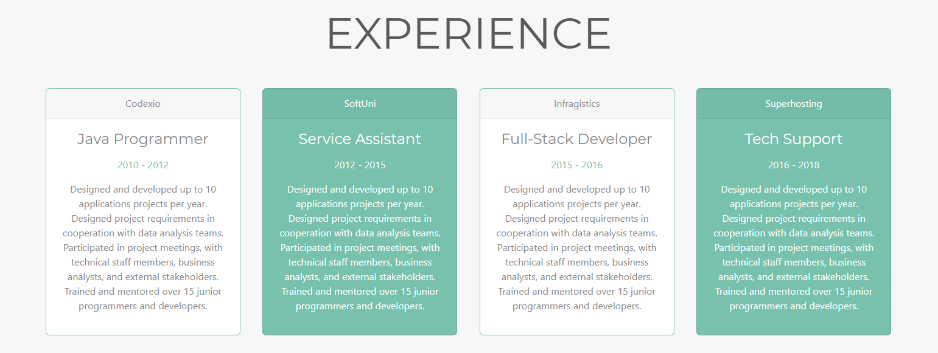

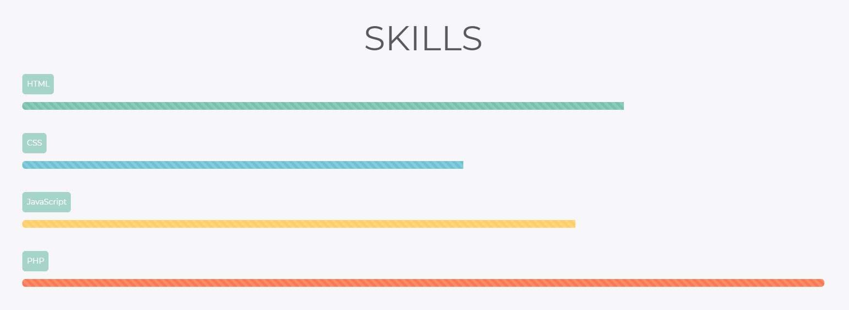

## Bootstrap and jQuery Plugins

So now the easy job is done. It is time for some real coding. We should import a few custom plugins to our **Portfolio** **site**.

## 5.1 Bootstrap Collapse

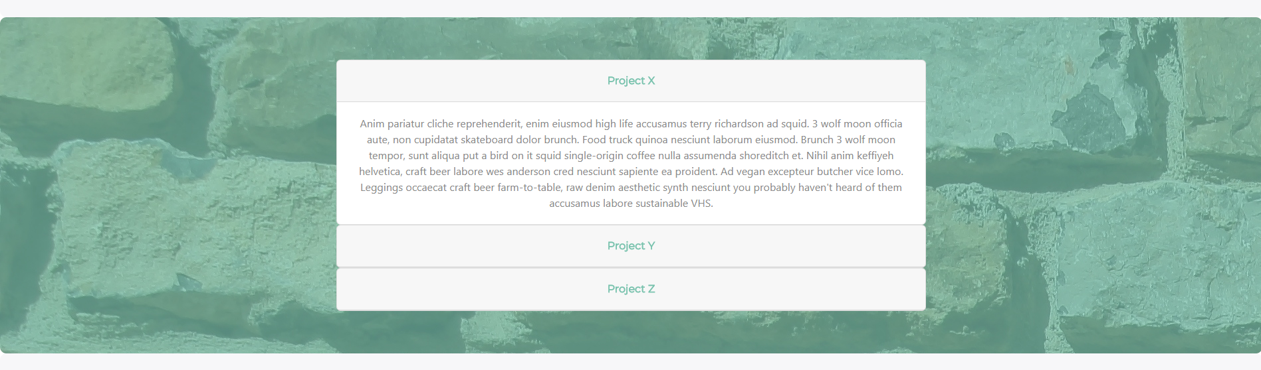

The next section we need to implement is the **Projects** section. In **this** section we should use the **collapse** **component**. You can read more about it [here](https://getbootstrap.com/docs/4.0/components/collapse/).

We need to import our **bootstrap.bundle.js** file and [jQuery](https://jquery.com/) library.

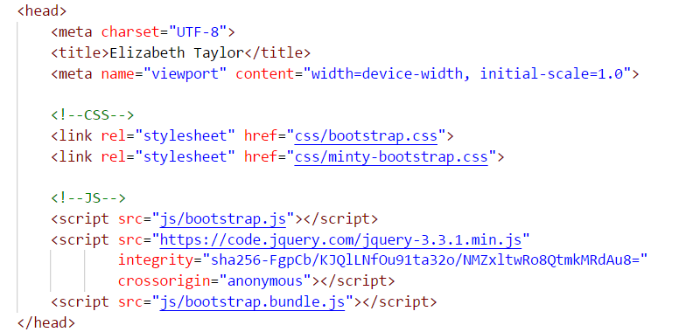

The next section we need to implement is the **Contact** section. In **this** section we need to implement a **simple form** which we can **reuse** from the **theme documentation**.

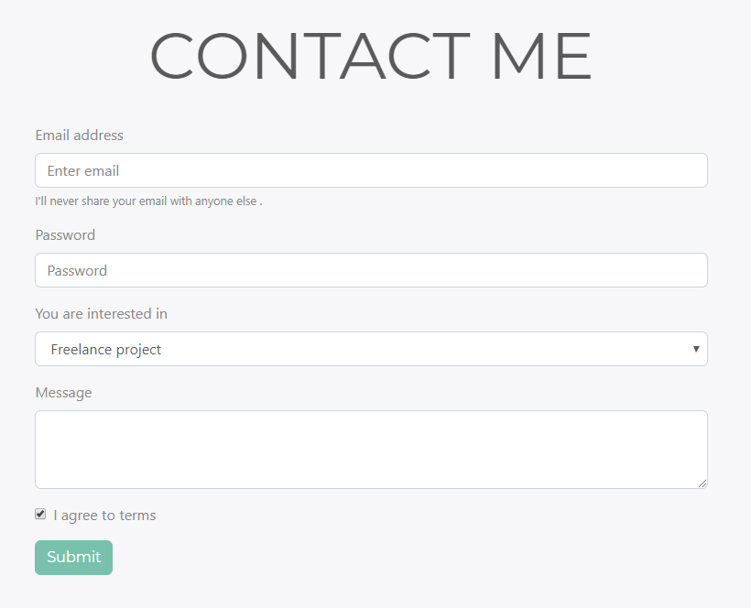 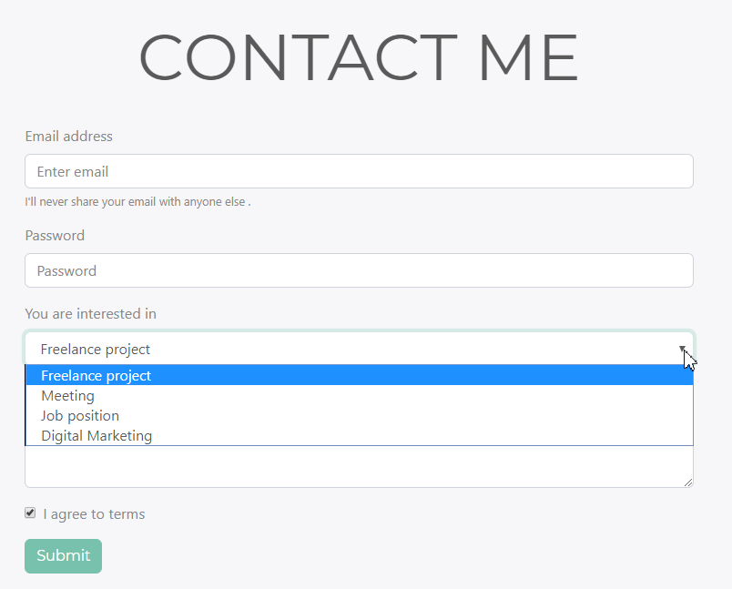

## Smooth Scroll with jQuery

After you create your **navigation** **bar** it’s time to **upgrade** it and to implement **smooth** **scroll** to it. You can use some **plugin** to do that or you can do it with this simple piece of **jQuery** code:

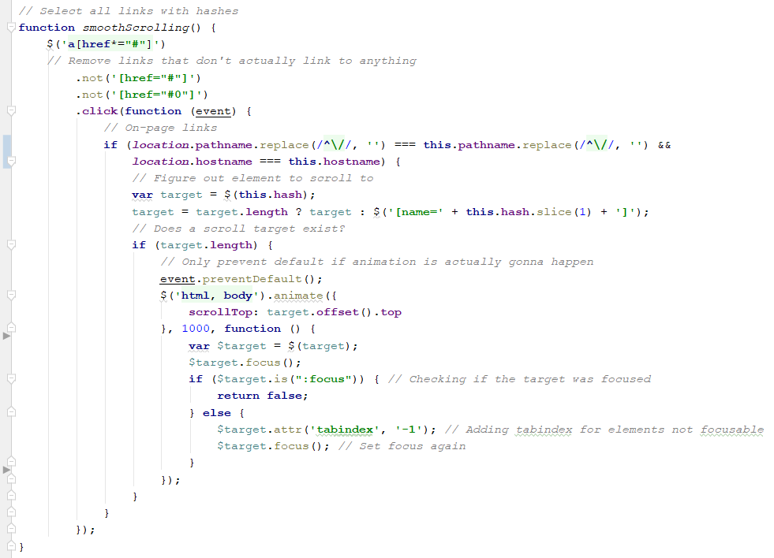

You can also find different [solutions](https://css-tricks.com/snippets/jquery/smooth-scrolling/) to this problem, if you search a little.

## Favicon

To have you portfolio site **completed**, you should also have a **favicon**. You can use [favicon generator](https://realfavicongenerator.net/) online and upload some of your photos **there**:

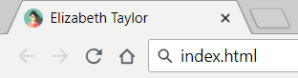

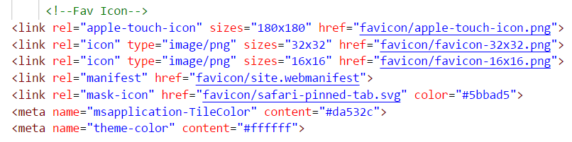

## Github Pages

After you have created this awesome portfolio it’s time to show it to the world. You can **host** your **simple** **static** portfolio in [Github Pages](https://pages.github.com/). You should **create a repository** (like **username.github.io**), where username is your **portfolio-based name**.

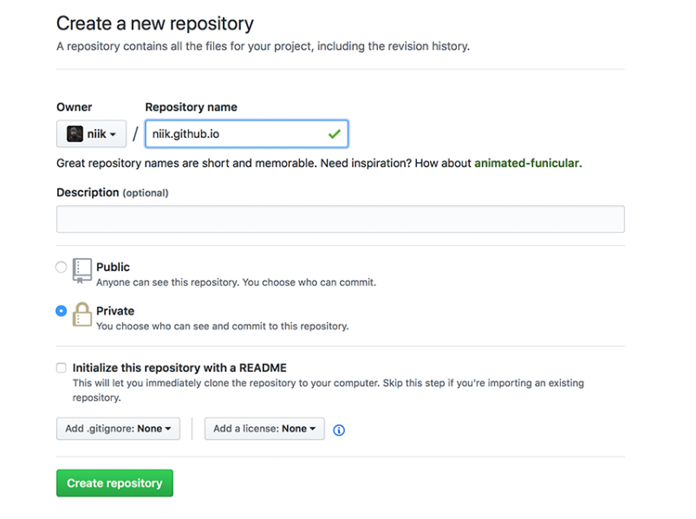

If you haven’t used any **Git** **client** we recommend you to download [GitHub Desktop](https://desktop.github.com/). **Clone** the repository you created and move your **portfolio** **project** there.

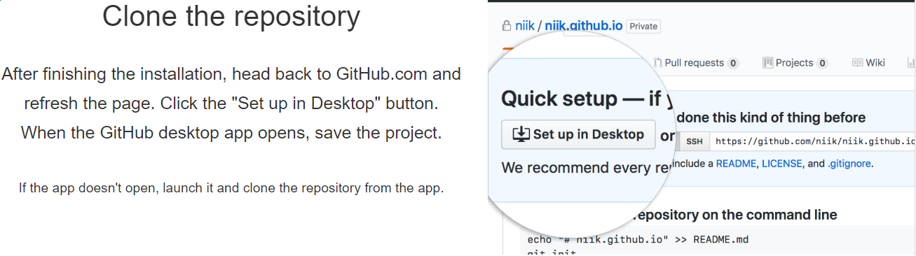

Enter the repository, **commit** your changes, and press the [**Publish**] button.

Fire up a browser and go to [**https://my-portfolio.github.io**](https://my-portfolio.github.io). Congratulations, now you can send it to everyone!